Fluid Network Analysis
Introduction
This tutorial was created using ANSYS 16.1. The purpose of this tutorial is to determine pressure at nodes and flow rates in pipes for given fluid flow network.
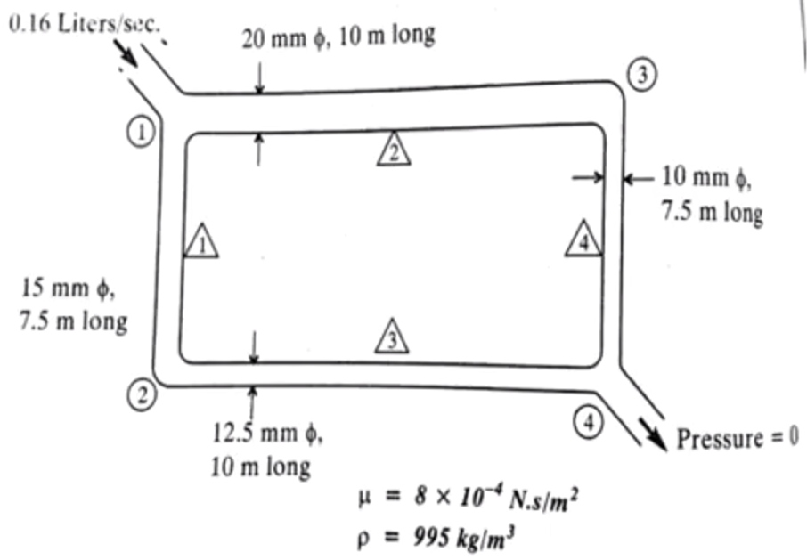
Define the Preferences
- Select Preferences.
- The following window will appear. Select ‘ANSYS Fluid’ as shown.
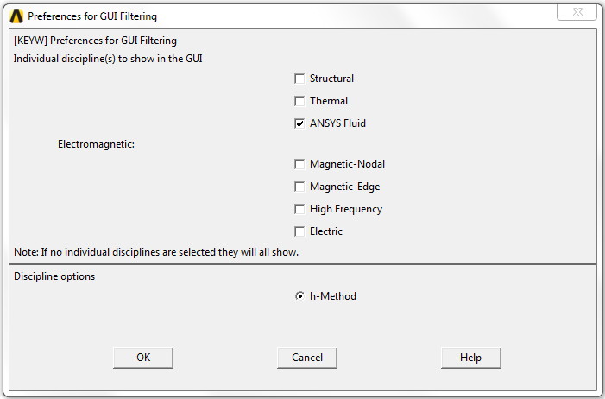
Define the Element Type
- Select Preprocessor>Element Type>Add/Edit/Delete.
- The following window will appear. Select ‘Add’.
- Use ANSYS Fluid>3D Viscous Link 138.

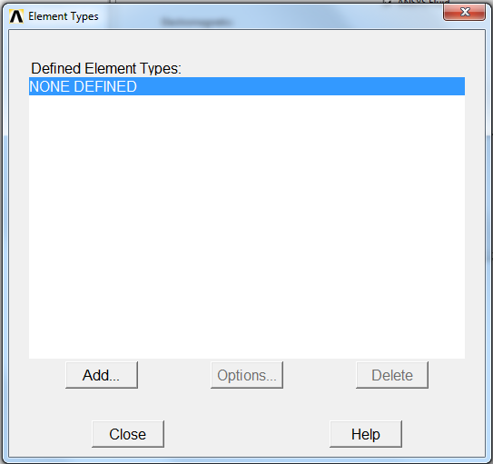
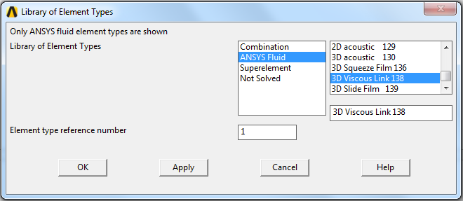
Define the Real Constants (Radius and length of each pipe)
- Select Preprocessor>Real Constants> Add/Edit/Delete.
- The following window will appear. Select ‘Add’.
- Then select ‘Type 1 FLUID138’ and click ‘OK’.
- Define the size of the first pipe with DIM1 and DIM2 are 7.5e-3 and 7.5 separately.
- Repeat this process for another three times for other pipes 2, 3, and 4 as shown.
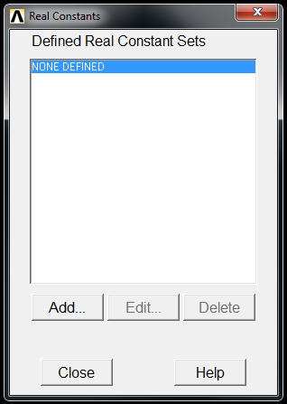
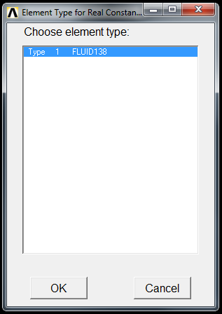

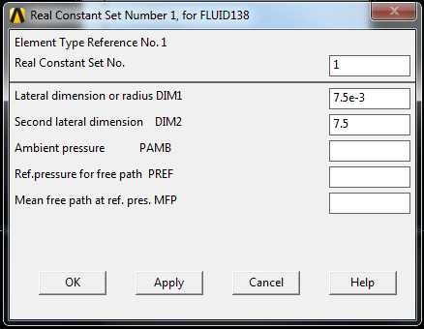
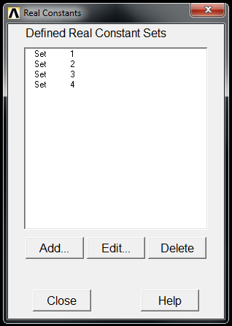
Define the Material Properties
- Select Preprocessor>Material Props> Material Models. The following window will appear.
- Select Material Model Number 1>Fluids>Viscosity.
- The VISC value is 8e-4.
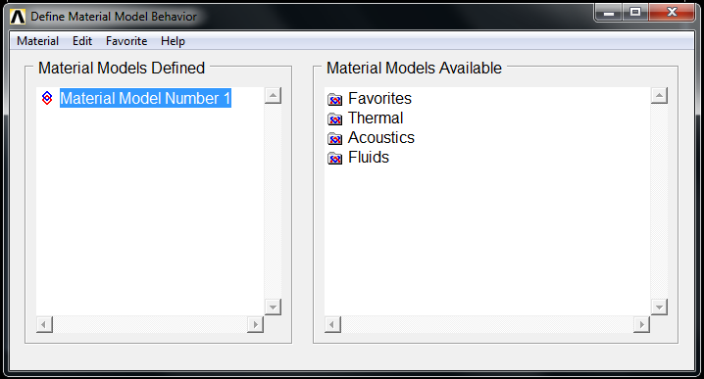
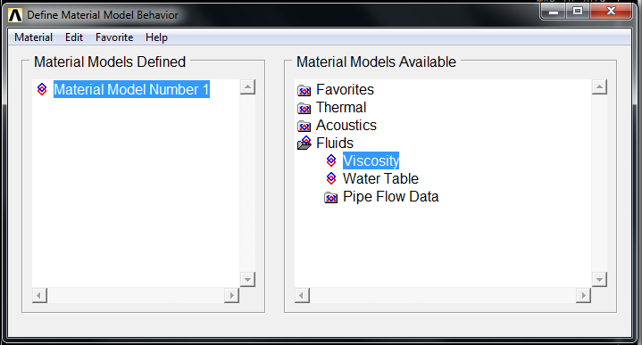

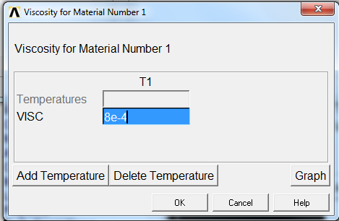
Define the Nodes
- Select Preprocessor>Modeling>Create>Nodes>In Active CS and the following window will appear.
- Define the location of the first node with coordinate of (0, 0) and click ‘Apply’.
- Repeat this process for another three times for Node 2, 3, and 4 with coordinates of (0, -7.5) (10, 0) (10, -7.5) separately.
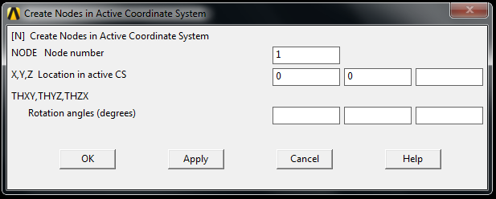
Define the Elements
- Select Preprocessor>Modeling>Create>Elements>Auto Numbered>Thru Nodes. Select Node 1 and Node 2 and click ‘OK’ so the Element 1 is defined.
- Select Preprocessor>Modeling>Create>Elements>Elem Attributes and the following window will appear. Choose Real constant set number ‘1’ for the Element 1.
- Repeat these processes for another three times. Connect Node 1 and Node 3 for Element 2, Node 1 and Node 2 for Element 3, and Node 3 and Node 4 for Element 4. The Real constant set number is 2, 3, and 4 separately.
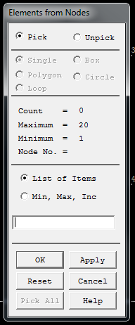
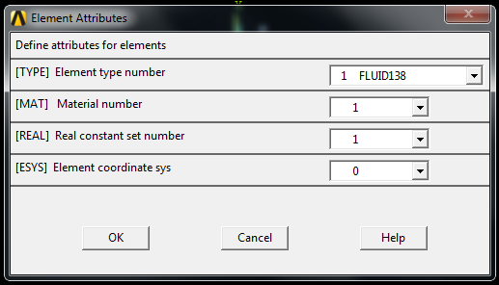
Define the Loads
- Select Preprocessor>Loads>Define Loads>Apply>Fluid/ANSYS>Pressure DOF>On Nodes. Choose Node 4 and the following window will appear. Use PRES Pressure value ‘0’.
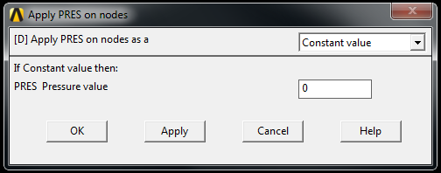
- Select Preprocessor>Loads>Define Loads>Apply>Fluid/ANSYS>Flow>On Nodes. Choose Node 1 and the following window will appear. Use FLOW Load value ‘0.16e-4’.
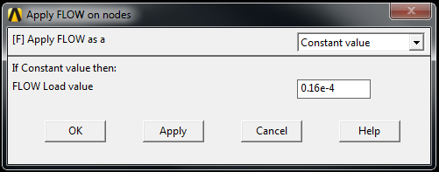
Define the Analysis Type
- Select Solution>Analysis Type>New Analysis and the following window will appear. Choose ‘Steady-State’.
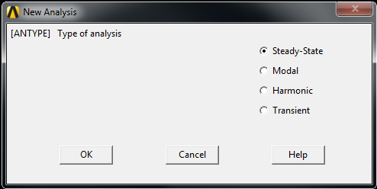
Solve the problem
- Select Solution>Solve>Current LS.
Check the results
- Select General Postproc>Plot Results>Contour Plot>Nodal Solu and the following window will appear. Choose Nodal Solution>DOF Solution>Pressure and Click ‘OK’.
- Select General Postproc>List Results> Nodal Solution and the following window will appear. Choose Nodal Solution>DOF Solution>Pressure and Click ‘OK’.
